LGA Personal Finance / Economics Class
Vocabulary and Notes
What is Demand? – February 19

Demand – the desire, willingness, and ability to buy a good or service
*For demand to exist –
-A customer must want a good or service
-A customer has to be willing to buy a good or service
-A customer must have the resources to buy a good or service

demand schedule – a table that lists various quantities of a product or service that someone is willing to buy over range of possible prices
demand curve – a graph that shows the amount of a product that would be bought at all possible prices on the vertical axis and quantities on the horizontal axis.
*Each point in the curve shows how many units of the product or service an individual will buy at a particular price
Demand Schedule Demand Curve
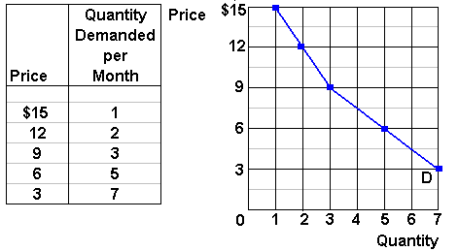
Law of Demand – quantity demanded and price move in opposite directions

market demand – the total demand of all consumers for their product or service
*knowledge of demand is important for answering the questions of production
utlitity – the pleasure, usefulness, or satisfaction we get from using a product
*may vary from person to person
*usually changes as we consume more of a particular product
*because you are not quite as hungry after consuming the first slice, you receive less additional satisfaction or marginal utility for each additional slice.
Diminishing marginal utility – the principle that our additional satisfaction, or our marginal utility, tends to go down as more and more units are consumed
Buyer’s market – when an abundance of goods exists, buyers can afford to be selective and sellers usually have to lower prices to lure customers

Changes in Demand
*changes in number of consumers
*changes in consumers’ income
*changes in consumers’ taste
*changes in consumers’ expectations
-expectations – the way people think about the future
*changes in substitutes
-substitutes – competing products that can be used in place of the other
*changes in compliments
-compliments – products that are used together (computers/software, dvds/dvd players)

Elasticity of Demand
Demand elasticity – extent to which a change in price causes a change in the quantity demanded
*to be elastic means that each change in price causes a relatively larger percentage change in quantity demanded
*items with substitutes are usually elastic because there is a choice
*items with few or no substitutes are inelastic (medication, electricity, Turkey at Thanksgiving)

