LGA Personal Finance / Economics Class
Vocabulary and Notes
Supply

Supply – the various quantities of a good or service that producers are willing to sell at all possible market prices
*can refer to one since business/producer or it is all possible to be supply for the entire market
Law of Supply – the principle that suppliers will normally offer more for sale at higher prices and less at lower prices
supply schedule – a numerical chart that illustrates the law of supply
supply curve – a graph that shows the amount of a product that would be supplied at all possible prices in the market
*slopes upward to reflect the fact that suppliers are generally willing to offer more goods and services at a higher price and fewer at a lower price
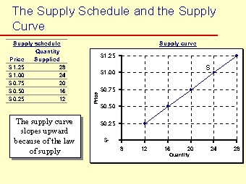

Profit – the money a business receives for its products or services over and above its costs
Market supply – the total of combining the supply schedules of all businesses that provide the same good or service

Changes in Supply
*changes in the cost of resources
*changes in productivity
-productivity – the degree to which resources are being used efficiently to produce goods and services
*changes in technology
-technology – the methods or processes used to make goods and services
*changes in government policies
*changes in taxes and subsidies
-subsidy – a government payment to an individual, business, or other group for certain actions
-example – farm subsidy of $2 for every bushel of corn would lower the cost of production and encourage producers to remain in the market and new producers to enter, but when subsidies are repealed, costs go up, producers leave the market, and the supply curve shifts to the left

Elasticity of Supply
Supply elasticity –a measure of how the quantity supplied of a good or service changes in response to changes in price

Supply and Demand at Work
*A supply curve and be combined with a demand curve to analyze the price adjustment process.

Surplus – the amount by which the quantity supplied is higher than the quantity demanded
Shortage – the amount by which the quantity demanded is higher than the quantity supplied
Equilibrium price – the point where supply and demand are balanced
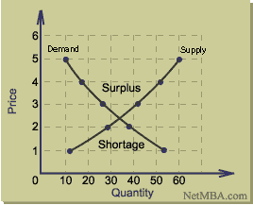
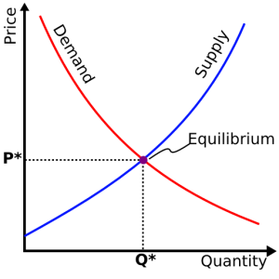

Price Controls – government-set price because they believe forces of supply and demand are unfair. This can favor the consumer or producer.
Price Ceiling – government-set maximum price that can be charged for goods and services
Price Floor – government minimum price that can be charged for goods and services
*more common than price ceiling
*example – minimum wage

Prices as Signals
*They help businesses and consumers make decisions
*Help answer the three basic economic questions
*Without prices, the economy would not run as smoothly and decisions would have to be made another way
*Prices are neutral – prices in a competitive market favor neither the producer or the consumer. The more competitive the market, the more efficient the price adjustment process.
*Prices are flexible – market economy price system can absorb unexpected shocks like war or natural disasters
*Prices and freedom of choice – variety of products at a wide-range of prices; no one forces the consumer to pay a certain price for a product
*Prices are familiar – easily understood

